Tab 1

**Table of Contents**

**Our Mission 2**

**Introductions 3**

**Slides 4**

**Data Flow Diagram 18**

**TV Needs 19**

**Laptop for central control 20**

**Why you could need a TV 21**

**Audio Solutions 22**

**Gantt Chart 23**

**Interview Notes 25**

**Our Mission**

To provide good technology solutions, at an affordable price

**William Brown**

**Centralization and Hardware**

Computer Analyst and Web Programming

AAS at NICC

2nd Year at NICC

**Johnathan Ervin**

**Audio Solutions**

AAS Computer Business & Web Programming

Audio Engineering Specialist/ Asylum Studio

**Reece Reiger**

**Relocation / Visuals**

2nd year student

I am currently in school for Business Development and Web Programming and will be graduating in May

**Austin Kennedy**

**Networking/Wix Compatibility Consultant**

AA and AGS at NICC in 2021

2nd year in Networking at NICC

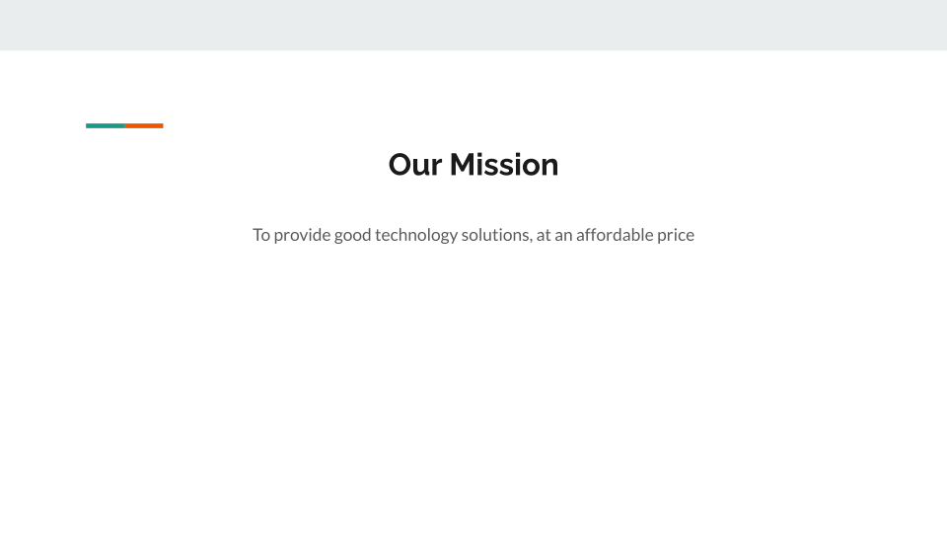

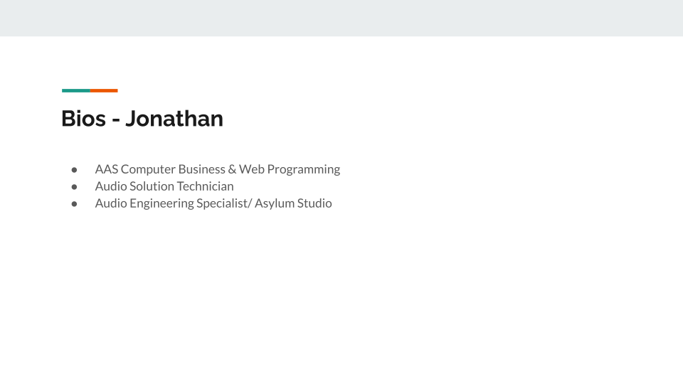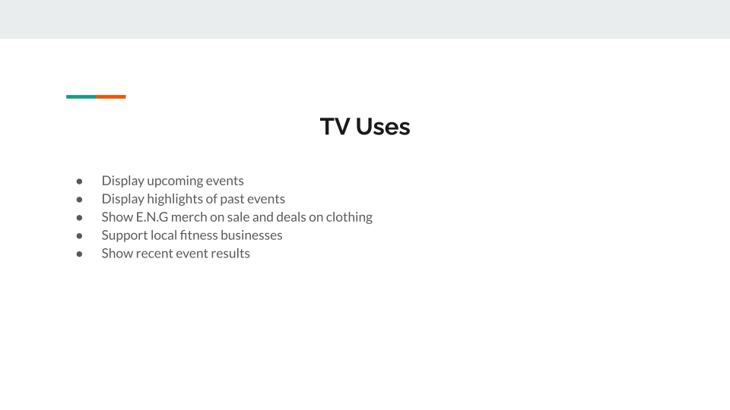

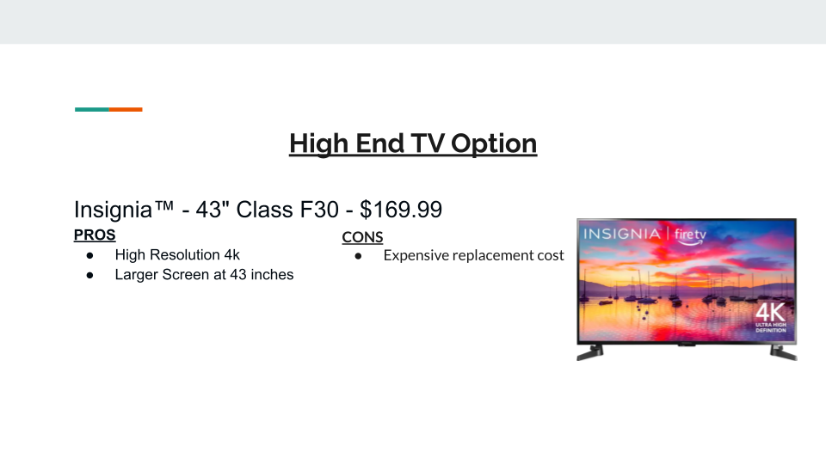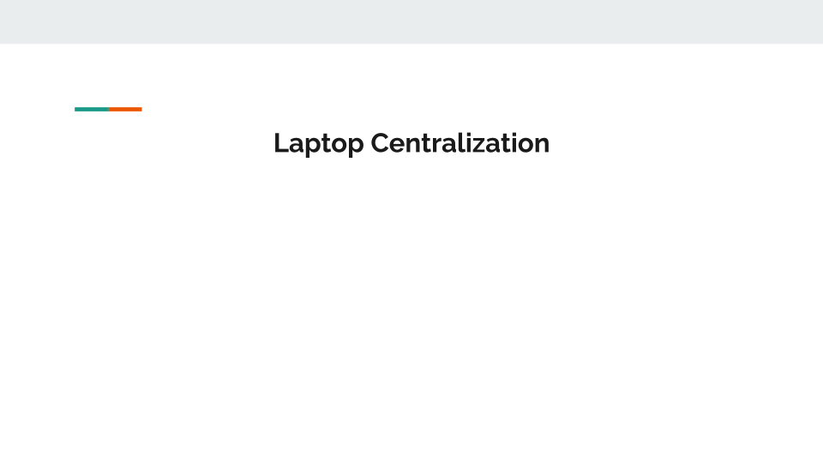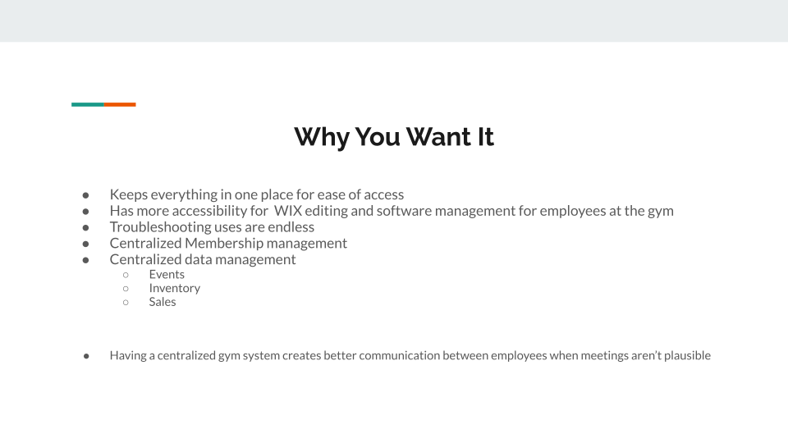

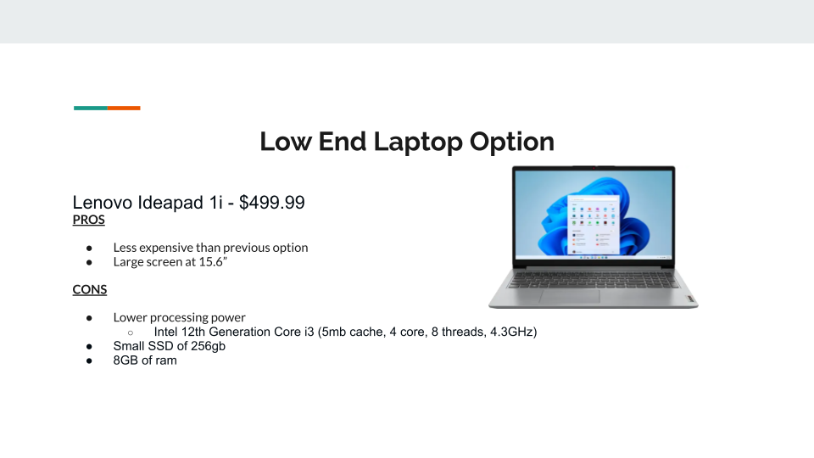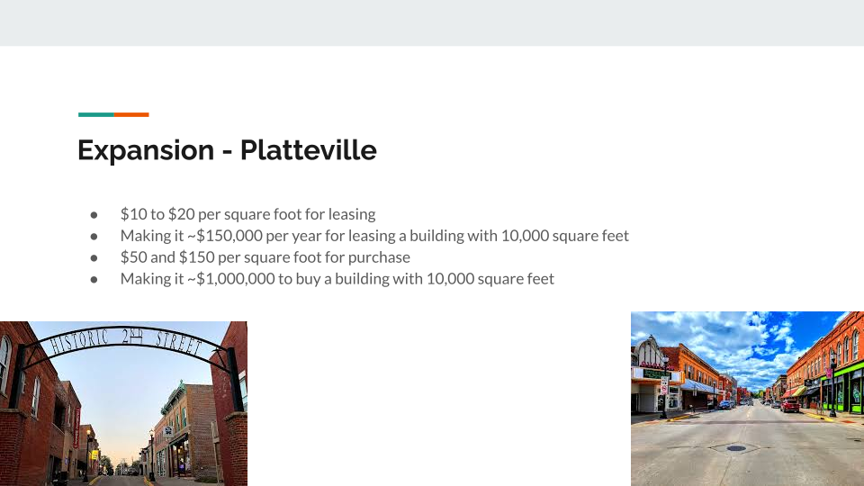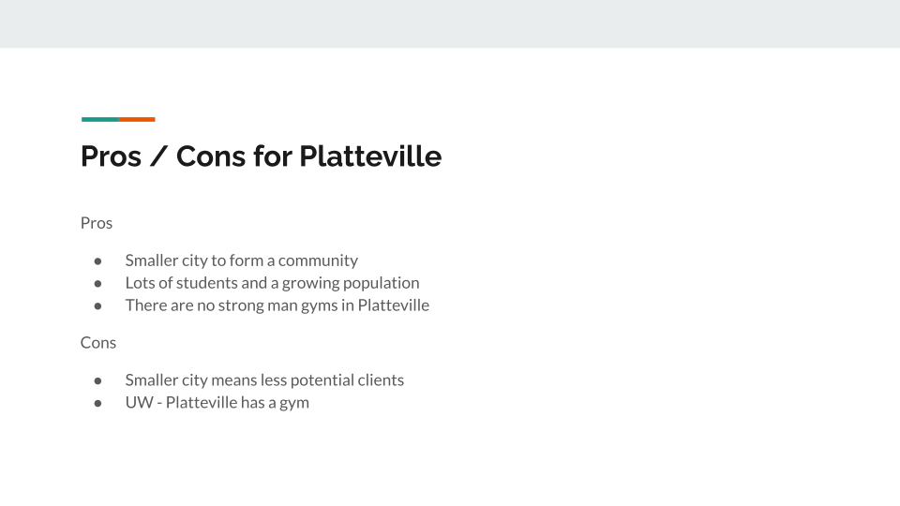

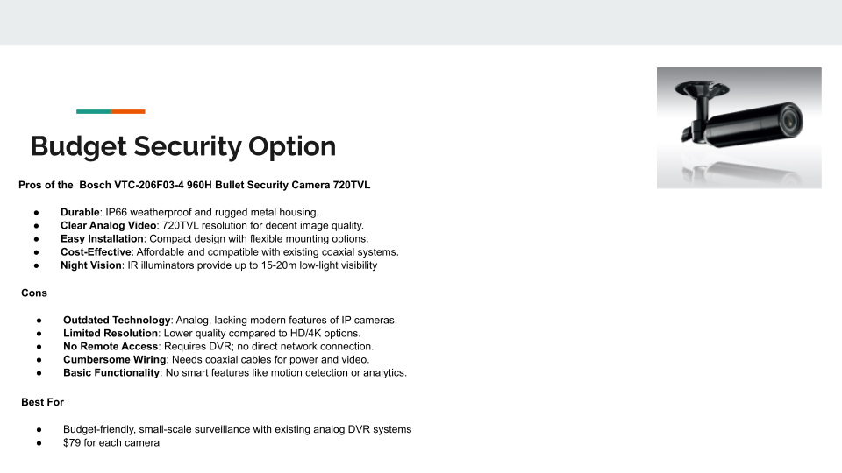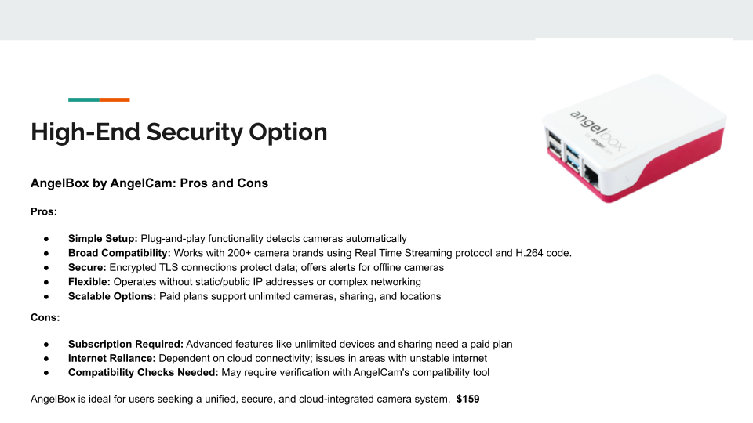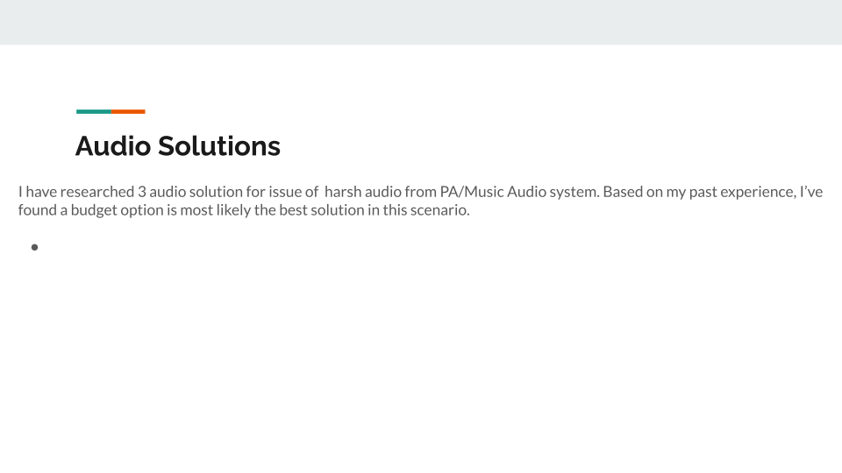

**Data Flow Diagram**

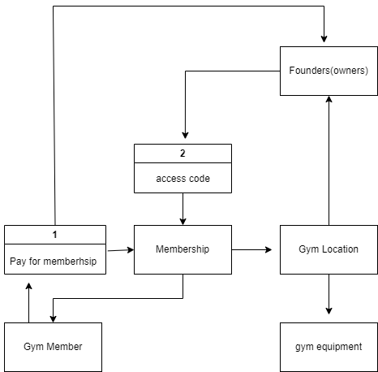

**TV Needs**

# Insignia™ - 32" Class F20 Series LED HD Smart Fire TV - $79.99

# Best Buy essentials™ - Tilting TV Wall Mount for Up to 50" TVs - $20

**Laptop for central control**

Dell Precision 5530 15.6" LCD Mobile Workstation with Intel Core i7-8850H 2.6 GHz, 16GB RAM, 512GB SSD - $349.99

Dell Inspiron 16 Laptop AMD Ryzen™ 7 8840U 8-core/16-thread Processor with Radeon™ Graphics - $699.99

**Uses for the laptop**

Having a laptop in your business can be used for many things, like tickets for maintenance or better centralized control over camera systems and updating hardware and software within the gym with the keypad or sound system or the in house entertainment.

Peavy makes a DI box that takes USB from the computer and converts it to XLR out. - **Peavey USB-P USB Playback Device - $79.99 - This could be a replacement for the existing bluetooth player with the laptop combined.**

**Why you could need a TV**

Provide entertainment in the gym, display upcoming events, social media posts in real time, highlights from meets, advertisement for apparel or even displaying music being played.

**Audio Solutions**

Rockville 2 WET-6525B 6.5" 70V Commercial Indoor/Outdoor Wall Speakers in Black - $139.95 for 2 speakers - 40 watts 4 way swivel wall mount.

Use existing PA system but move it to more sheet metal friendly areas and limit volume to eliminate ear blasting. Use laptop to mix or get a inbetween mixing modules to keep it from getting too loud.

# **Harbinger LV7 7-Channel Analog Mixer With Bluetooth - $64.99**

This would be the best budget option to control sound EQ and mixing without being complicated or sacrificing quality for budgeting. Could connect existing bluetooth connection dongle to it and hide the EQ in the closet. Many people play music extremely loud with poor EQ causing irritation in others, with this concern even if mentioned to the user they can only turn down their music to solve the issue when its really an EQ issue.

**Gantt Chart**

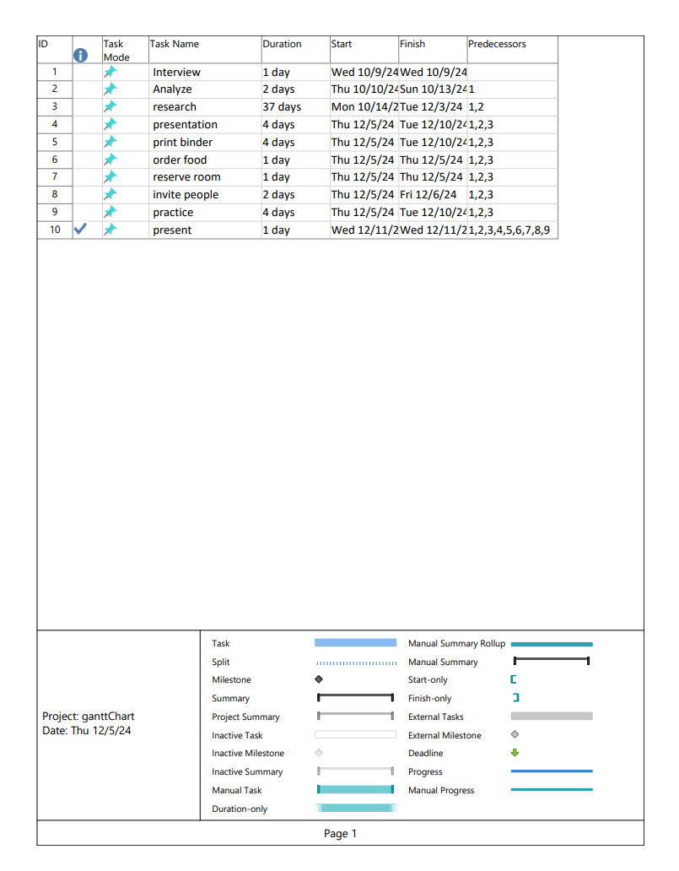

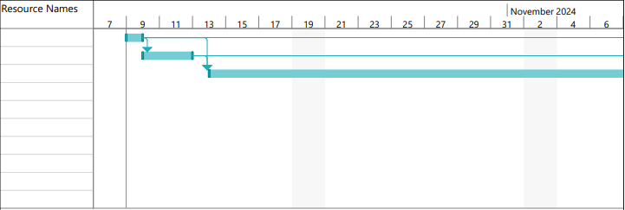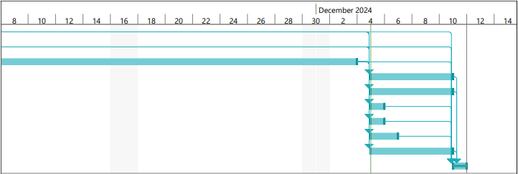

**Interview Notes**



**Questions**

What would you like to get out of this? Just because

Is there anything that you are currently not satisfied with in terms of hardware/software? Open to finishing up on ID cards- looking at cost of it

Hardware: Built-in sound system (Sound-proofing)

Software: Wix (Financial), HISSEEU(Door access)

Would you like to expand?

Would love to; at least another location outside of Dubuque; move to a bigger location in Dubuque from current location.

* Currently 4,000 square ft; looking for 8,000 square ft area for competition instead of renting.
* In a market that doesn’t have a strongman gym.
* From 40 - 50 members up to 100 because of location change (~250 members currently)
* Used to be on Peru Rd.
* Rent is really cheap: 2019 rates
* Might raise membership rates if location moved to 10,000 square foot location by $5, then eventually to $10

Would you like to expand your website? Definitely needs to be updated. Events?

* Everyone that does something for the gym is volunteer-based
* Everyone is closer to each other compared to commercial gyms
* Possibly add a forum (community section) to state opinions
* Polls for events
* QR codes (don’t want to have a comment section)

Have you had any problems with the website?

Have any customers had comments on technology in the gym?

* Keypad works unless it gets really hot; doesn’t respond
* Argued that they swapped out the stereo system and claimed it didn’t work
* Replaced the keypad already
* Would like another bathroom
* RFID Cards going out

Do people have a way of forwarding ideas to people in charge?

* Facebook group chat, gym Facebook page, gym email, Instagram

Have you had any technology related ideas that you didn't know how to implement that we could help you with?

* Getting a couple of TV’s set up to show highlight reel of members getting PR’s (Dynamic monitors)
* Kiosk modes on them
* Great way to advertise events, birthdays, any info that’s interesting

Do you have concerns about security? cameras?

Have you been interested in changing or working on the 24/7 sign-in system? Have ID cards, haven’t fully set up

Would you be interested in getting more involved with social media?

* Instagram more than Facebook (2 to 3 times daily)
* Facebook (1 to 2 times bi-weekly); more events and clothing options
* Anytime they get tagged on people’s stories on Instagram, not really posts
* Using Printly for merchandise (Clothing); price for quality

Where is the information for members stored?

* Wix (Can email all contacts),
* Text alerts for time to buy merchandise, event dates, reminder to pay memberships

Contacts for gym?

* Gym Email
* Google phone number to go to owners

Option to have one employee on site?

* Thought about it but cost got in the way

Repair ticket system for broken items?

* QR codes to report broken items; keep anonymous but option of stating member name

Misc.

* Good on Internet connection and strength
* Access cameras on phone (Good quality cameras)
* App for cameras ()

Platteville generally range from $10 to $20 per square foot for lease. Purchase prices can be higher, often between $50 and $150 per square foot, depending on the condition, amenities, and location.